CS/EE 120B

Custom Project: Ethernet-connection

Jonas Sorgenfrei

Mai 4, 2018

# Introduction

The general idea of this project is to establish an ethernet connection between the ATmega and a local network.

The LCD-Panel should always show he IP-Address of the ethernet shield should may be adjustable with 3 buttons. The Port should be hard coded to the ATmega.

In general, the IP-Address should be static. (If everything works fine, I’ll may add the possibility to use DHCP as well)

To connect to the Device, I’ll write a small QT-Interface Application in C++.

I’ll use UDP for the connection. (If everything works fine, I’ll may change to TCP).

This is the general/main part of the project.

To add a little bit more visibility and interaction, I decided to use a TFT Touch Screen as Output and may be as input as well.

The touch screen should print the incoming UDP/(TCP)-Query and on trigger it should send a Query to the connected computer with the coordinates of the klick. (If everything works fine, I’ll add the possibility to send an image [converted to a Matrix] from the computer to the screen, which will be shown on it).

Additionally, there will be a few RGB LEDs connected to the ATmega.

Using an RGB color selector on the client computer it’s possible to adjust the colors of the RGB LEDs.

# Components (Pin-out)

* **Inputs**
  + Ethernet Shield (PORT/PIN D)
  + Buttons 3 (PORTA(Lower4))
  + TFT Touch Screen (PORTC)
* **Outputs**
  + Ethernet Shield (PORT/PIN D)
  + RGB LEDs (PORTA(Upper4))
  + LCD-Display (PORTC (PORT-D Control)
  + TFT Touch Screen (PORTC)

For the ethernet shield I’ll modify one of this existing (Arudino)-Libraries: ether_28J69, etherShield, etherCard, UIPEthernet

# Complexities/Build-upons

1. Using the ENC28J60 Ethernet Shield for connecting the Atmega to the LAN-Network

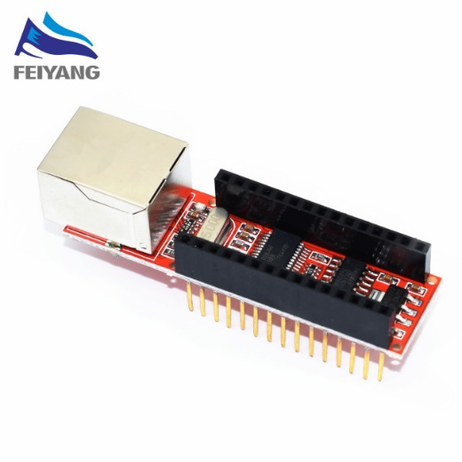

1. Using an TFT touch LCD Module for output and input

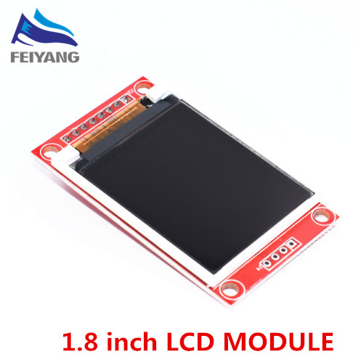

1. Using RGB LEDs which can be controlled in Color and Brightness (PWM) via UDP by a Software-Interface which runs on a computer or/and by the touch LCD Module

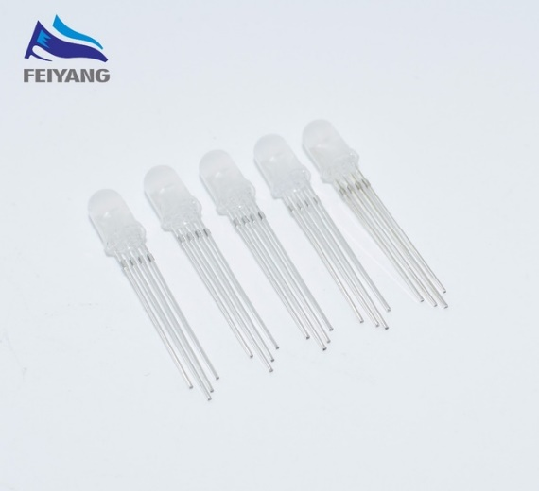

1. Using LCD-Panel showing IP-Address, maybe adjustable via 3 buttons or changeable from IP, to Mac, to Port